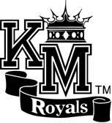

# Profile

Kent- Meridian High School

CEEB code: 480-535

Main Office: (253) 373-7405

Counseling Office: (253) 373-7436 <http://www.kent.k12.wa.us/ksd/km/>Principal: Dr. Wade Barringer

School Counselors: Patricia Moss, Wanda Howlett, Betsy Schelien, Kelly McGuinness, Kevin Barker

# Community

Kent School District is the fourth largest school district in the state of Washington, serving the communities of Kent, Covington, Renton, Maple Valley and Black Diamond. The district benefits from a wide range of economic energy resulting from its location at the midway point between Seattle and Tacoma. Currently, the district consists of four large comprehensive high schools, six middle schools, twenty-eight elementary schools and five academies. Kent School District benefits from a wealth of diversity as more than 137 languages are spoken within its boundaries, with the top five languages being: Spanish, Ukrainian, Arabic, Somali, and Vietnamese. The

Kent School District’s student population consists of 64% students of color and 36% Caucasian students. Kent-Meridian High School itself has been identified as the most diverse high school in Washington State and currently contains 20% Asian, 33% Hispanic, 19% Black, 17% White, 4% Pacific Islander, 7% who identify as multiracial and <1% American Indian/Alaskan Native.

In addition to the cultural and linguistic diversity of the Kent School District, Kent-Meridian High School addresses a wide range of academic diversities. When comparing the free and reduced lunch data from the Office of the Superintendent of Public Instruction, it should be noted that statewide, 45% of students receive free and reduced lunch. Similarly, within Kent School District, the number is 52%. This is a sharp contrast to the 75% at Kent-Meridian High School indicating an increased socioeconomic diversity.

# School

Kent-Meridian High School is an urban, comprehensive, four-year public high school enrolling 2000 students (on average) in grades 9 through 12. KM serves families from over 100 different countries, who speak over seventy different languages. KM prides itself on its diversity and acceptance of all. The school opened in 1951 and graduated its first class in that same year. Currently, Kent-Meridian High School is nationally accredited by the National Association of Accredited Schools and the International Baccalaureate World School Association. Our mission statement is specifically designed to address our population as well as the variety of programs we support.

*“KM students are prepared with the knowledge and skills necessary to successfully take on the*

*responsibilities of college, career, family, and citizenship in a diverse and increasingly competitive global society.”*

**Curriculum**

Kent Meridian’s academic program consists of six periods per day that average fifty-five minutes. Students earn .5 credit for each class each semester, or on average, six credits per year.

The International Baccalaureate Diploma Program is recognized worldwide for providing 11th- and

12th- grade students with a challenging, college preparatory curriculum. Kent-Meridian offers the **International Baccalaureate (IB) Diploma Program.** Students who choose to become **IB Diploma Candidates** complete course work and assessments in seven curricular areas during their junior/senior years. Additionally, students must write an extended research essay of four thousand words and fulfill requirements within a program component known as *Creativity, Activity, and Service*. The IB Diploma Program is available to **all** students in the Kent School District who choose to open enroll at KM, and our IB classes clearly match our general demographics. Students and parents must recognize that success depends on a commitment to academic work during the 11th and 12th grade years. Solid academic skills, the willingness to manage one’s time, and motivation are essential requirements for Diploma Program.

Since the inception of the **International Baccalaureate** program at Kent-Meridian in 2005, thousands of students have participated in the **IB** programto some degree. Statistical analysis between the start year of 2005 and the current year of 2016 demonstrates the positive growth within the program. Overall, there has been consistent growth in student enrollment and completion through the issuance of an **International Baccalaureate Diploma.** Additionally, there have been clear gains in the number of **International Baccalaureate** tests administered. The program continues to grow and has become an integral piece of the academic culture provided to students at Kent-Meridian High School. This trend is also demonstrated by the fact that since 2005 the number of **International Baccalaureate** classes available to students has increased from 8 to 40 classes. Testing results for these exams are shown in Table 1.

**Table 1: International Baccalaureate examination results over the last twelve years**

|  |  |  |  |  |  |  |  |  |
| --- | --- | --- | --- | --- | --- | --- | --- | --- |
| Year | Number of Diploma  Candidates | Number of  Diplomas  Awarded | Number of  Anticipated  Candidates* | Number of  Certificate  Candidates | Total number of  candidates examined | Number of  HL exams written | Number of  SL exams written | Total number of exams written |
| 2005 | 1 | 1 | 0 | 21 | 22 | 38 | 3 | 41 |
| 2006 | 2 | 0 | 1 | 42 | 44 | 56 | 32 | 88 |
| 2007 | 5 | 5 | 12 | 32 | 37 | 67 | 37 | 104 |
| 2008 | 16 | 6 | 5 | 29 | 45 | 85 | 51 | 136 |
| 2009 | 10 | 10 | 6 | 31 | 41 | 85 | 51 | 136 |
| 2010 | 11 | 7 | 25 | 32 | 43 | 101 | 72 | 173 |
| 2011 | 15 | 9 | 25 | 36 | 51 | 114 | 79 | 192 |
| 2012 | 18 | 7 | 24 | 45 | 63 | 127 | 122 | 249 |
| 2013 | 21 | 18 | 32 | 28 | 49 | 116 | 79 | 195 |
| 2014 | 25 | 17 | 11 | 52 | 77 | 131 | 75 | 206 |
| 2015 | 9 | 5 | 19 | 45 | 54 | 102 | 68 | 170 |
| 2016 | 18 | 9 | 33 | 57 | 96 | 113 | 98 | 211 |
| 2017 | 22 | 12 | 33 | 37 | 90 | 107 | 105 | 212 |

IB STUDENT DEMOGRAPHICS

|  |  |  |  |  |  |  |  |  |  |  |  |
| --- | --- | --- | --- | --- | --- | --- | --- | --- | --- | --- | --- |
| Student Group | Sex | | Race | | | | | | SpEd | ELL | F/R |
| M | F | Black | Hawaiian | Latino | Multi | White | Asian |
| ALL KM STUDENTS ‘17 |  |  | 19% | 4% | 30% | 6% | 20% | 21% |  |  |  |
| ALL IB STUDENTS ‘17 | 46% | 54% | 17% | 4% | 34% | 8% | 17% | 20% | 1% | 4% |  |
| ALL IB STUDENTS ‘18 | 43% | 57% | 18% | 5% | 33% | 7% | 16% | 22% | 2% | 2% |  |
| DIPLOMA 2017 | 33% | 67% | 8% | 4% | 21% | 17% | 25% | 25% | 0% | 0% |  |
| DIPLOMA 2018 | 40% | 60% | 12% | 0% | 36% | 9% | 12% | 30% | 0% | 0% |  |
| DIPLOMA 2019 | 31% | 69% | 20% | 6% | 14% | 17% | 9% | 34% | 3% | 0% |  |

In Percentages:

Enrollment in the **Kent-Meridian Technology Academy (KMTA)** provides students options for following both college and career pathways. Students take most core and honors classes within the Academy and supplement their learning with electives and other graduation or college preparation requirements from options in the greater Kent-Meridian High School program.

Project-based learning, involving real world projects that develop student knowledge and skills, forms the primary instructional approach used by teachers in the Technology Academy. The key elements of 21st-Century learning include a focus on core subject knowledge, using 21st Century tools, connecting with the broader world, digital literacy, inventive thinking, effective digital-age communication skills, and high productivity. Students have access to advanced career-oriented software when completing project-based learning activities. By being challenged with the 21st-Century skills set and a more self-directed instructional approach, students acquire the skills they need to be both academically prepared and workforce ready when they graduate.

The Technology Academy embraces *Anytime Anywhere Learning*. This concept envisions students having complete access to laptop computers and the world of information available twenty-four hours a day. Students learn to use this access as easily as pencil and paper. The Academy environment creates a connected learning community where learning is not limited by the hours in the school day or the walls of the classroom.

Juniors and seniors may take **International Baccalaureate** courses to pursue college options within the KMTA setting and take AP Human Geography as sophomores. Additionally, junior and senior core classes in KMTA are scheduled later in the day to facilitate student participation in **Running Start** if desired.

**Running Start** is a program that allows qualified juniors (11.0 credits) and seniors the opportunity to enroll in college-level classes that apply to their high school graduation and university transfer or professional technical degree. In order to participate in Running Start, interested juniors and seniors must pass the COMPASS test at college level in Writing and Reading. Students who wish to enroll in college level mathematics courses must score at college level on the math portion of the COMPASS test. The grades and credits earned in college are part of the students’ permanent high school and college transcript. Students must obtain a minimum of a 2.0 GPA to qualify and maintain this level of competency to remain eligible for the program.

**College Preparatory** classes are also available. Courses available to students in this program will be accepted as college preparatory by virtually all colleges and universities in the state of Washington and throughout the United States. In addition to IB classes, we also have **Advanced Placement** classes – including AP Statistics, AP Human Geography, and AP World History. Students can also receive **CWU credits t**hrough the **Cornerstone program,** as well as **EWU** credits through the **EWU in the High School program** offered at Kent-Meridian High School. Students can earn up to 5 quarter credits per semester in the following subjects: Physics, Pre-Calculus, Calculus, Senior English, U.S. History, and advanced French. These credits transfer to all public universities and community colleges in Washington.

A variety of **Career and Technical Education (CTE)** courses are available to students: studio photo, digital design, computer technology, automotive, aviation, business/marketing, culinary arts, engineering, family and consumer sciences, health, metals and welding, theater/media, woods, and world languages.

Kent Meridian utilizes a **standards-based grading system**. Standards-based instruction and assessment is a proven approach to teaching and learning that clearly spells out what students should know and be able to do from one level to the next in all subjects.

**Kent-Meridian High School Expectations for Academic Rigor**

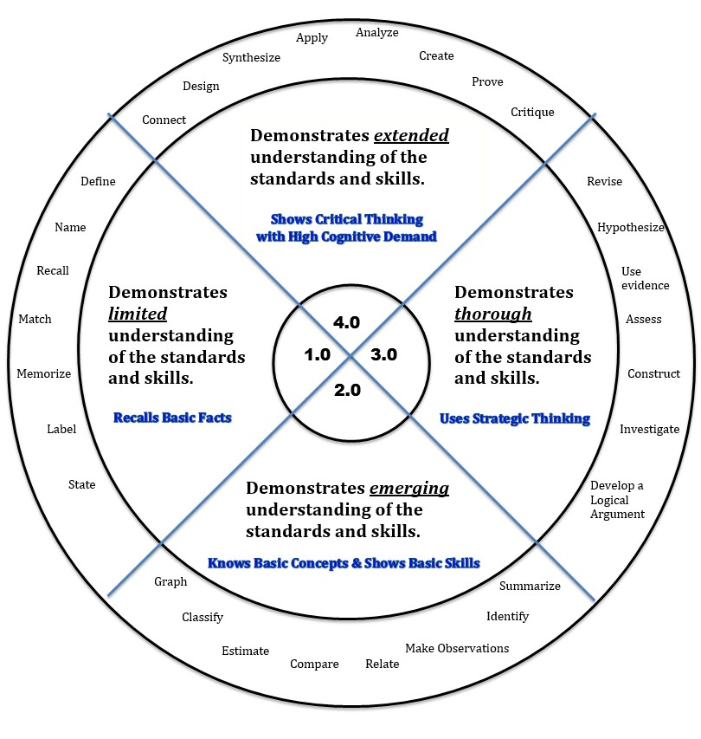

# Awards and Distinctions, 2010-15

* Most diverse school in the state of Washington
* WA State Achievement Index Exemplary School 2011
* WA State Achievement Award 2011- Extended Graduation Rate
* Level 4 Green School
* International Baccalaureate World School
* WA State Achievement Award 2013 and 2014- English Language Acquisition

# Academic and Student Programs

* Kent-Meridian HS advises 51 service, cultural and student activity clubs. Additionally, we house the following Academic programs to support student achievement.

|  |  |
| --- | --- |
| Associated Student Body (ASB) | Interact Club |
| Debate/Speech/Drama | Jazz Band/ Choir |
| College Success Foundation | Communities in Schools |
| DECA/Student Store | Key Club |
| Dream Project | National Honors Society |
| ELL English Language Learners | Orchestra |
| FBLA Future Business Leaders of America | PTSA |
| FCCLA Family Career Community Leaders of America | School Newspaper |
| Advanced Placement | EWU & CWU College in the High School |
| International Baccalaureate | Varsity Sports (18 Teams) |

**Colleges attended by Kent-Meridian graduates over the last four years**

* Art Institute of Seattle
* Bellevue College
* Bethel University
* UC Berkeley
* Blinn College
* Central College, Iowa
* Central Washington University
* Clark University
* Eastern Washington University
* Edmonds Community College
* Embry-Riddle Aeronautical University
* Everest College
* Everett Community College
* Evergreen State College
* George Fox University
* Gonzaga University
* Gordon College
* Green River Community College
* Harris-Stowe State University
* Hawaii Pacific University
* Highline Community College
* Idaho State University
* Ithaca College
* Jamestown College
* Johnson C. Smith University
* Lewis and Clark College
* Linfield College
* Metropolitan State College of Denver
* Northern Arizona University
* Ohio State University
* Olivet Nazarene University
* Pacific Lutheran University
* Pacific University
* Pierce Community College
* Pima Community College
* Renton Technical College
* Rutgers University
* San Francisco Art University
* Seattle Pacific University
* Seattle University
* South Seattle Community College
* Spokane Falls Community College
* St. Martin’s University
* Syracuse University
* Tacoma Community College
* Texas Southern University
* Trinity Lutheran University
* Union College
* University of Alaska, Anchorage
* University of California, San Diego
* University of Houston
* University of Montana
* University of Nevada Las Vegas
* University of Oregon
* University of Portland
* University of Puget Sound
* University of Washington
* University of Washington, Tacoma
* Vassar College
* Washington State University
* Western Washington University
* Westminster College
* Whatcom Community College
* Wheaton College
* Whitman College
* Whitworth University